SIMATS ENGINEERING
ASSESSMENT TOOL 1

COURSE CODE: MLA0304
COURSE NAME: Reinforcement learning for Environment and Agent

COURSE OUTCOME COVERED

CO5: Implement policy-based reinforcement learning methods to develop efficient solutions for complex environments. (BL2, BL3, BL6)

Assessment Tool Weightage: 35%

Dr DUMPALA PRASANTH

QUESTIONS: 10 Total Marks: 50

Annexure A

Simulation-Based Assessment Question
Duration: 1hr

- Simulate a Hierarchical Reinforcement Learning (HRL) agent for autonomous warehouse navigation.
( 5 Marks)

- Implement a Hierarchical Abstract Machine (HAM) to control a robot performing sequential tasks.
( 5 Marks)

- Develop the MAXQ Value Decomposition algorithm for a taxi navigation environment.
( 5 Marks)

- Simulate a Meta-Reinforcement Learning agent that rapidly adapts to multiple GridWorld environments.
( 5 Marks)

- Design a Multi-Agent Reinforcement Learning (MARL) system for cooperative robot path planning.
( 5 Marks)

- Implement a competitive Multi-Agent RL environment for autonomous drone navigation.
( 5 Marks)

- Simulate a Partially Observable Markov Decision Process (POMDP) for autonomous vehicle navigation under limited visibility.
( 5 Marks)

- Design an ethical Reinforcement Learning simulation for autonomous decision-making while satisfying safety constraints.
( 5 Marks)

- Develop an RL-based adaptive traffic signal control system and evaluate its performance.

- Simulate an RL-based smart energy management system for optimizing power distribution in a microgrid.. .
( 5 Marks)

Code of Conduct:

I ____M.Nandhini(192472318)________ (Name / Reg No) certify that this submission is my original work and that I have adhered to the guidelines specified for this assessment.
I understand that any violation of academic integrity rules will result in disciplinary action.

Signature of the student: M.Nandhini

Q1. Hierarchical Reinforcement Learning (HRL) for Autonomous Warehouse Navigation
1. Aim
To simulate a Hierarchical Reinforcement Learning agent for autonomous warehouse navigation by dividing the task into smaller subtasks.
2. Concept / Theory
HRL divides a complex RL problem into smaller tasks.
- High-level policy: Decides what task to perform.
- Low-level policy: Decides how to perform the task.
- In this program: Go to Shelf → Go to Packing Area.
3. Algorithm / Steps
- Create a 6×6 warehouse grid.
- Set the robot's starting position.
- Define the shelf and packing area.
- High-level policy selects a subtask.
- Low-level policy moves the robot toward the goal.
- Give rewards for reaching each goal.
- Continue until the robot reaches the packing area.
- Display the path and total reward.
4. Simple Python Code
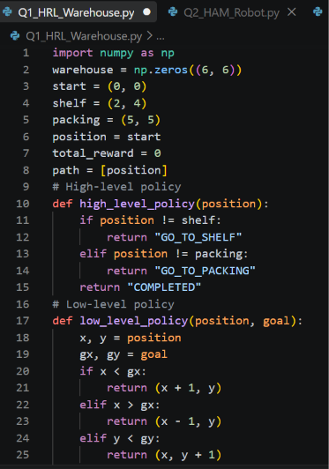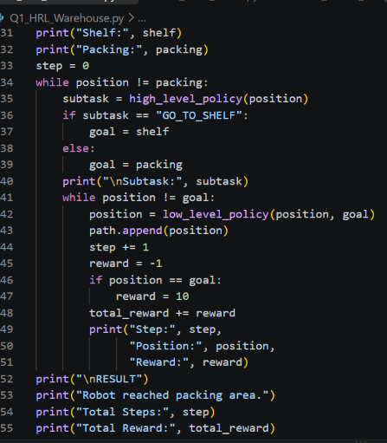
5. Expected Output
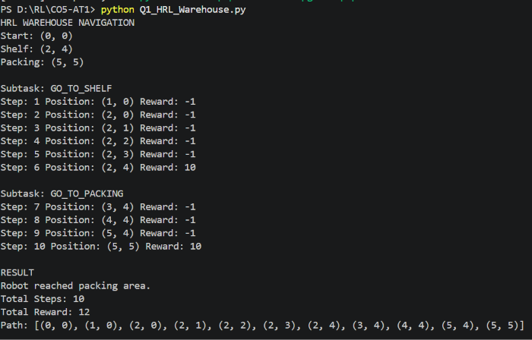
6. Short Viva Explanation
“This program simulates HRL for warehouse navigation. The task is divided into two subtasks: going to the shelf and going to the packing area. The high-level policy selects the subtask, while the low-level policy controls the robot's movement. The robot receives rewards for reaching the goals and finally reaches the packing area.”
7. Conclusion
The HRL agent successfully navigates the warehouse by breaking a complex task into smaller subtasks and using hierarchical decision-making.

Q2. Hierarchical Abstract Machine (HAM) for Sequential Robot Tasks
1. Aim
To implement a Hierarchical Abstract Machine (HAM) to control a robot performing sequential tasks.
2. Concept / Theory
HAM is a hierarchical RL framework where a robot follows a predefined task structure. The robot performs tasks in a specific sequence, such as:
Start → Move to Shelf → Pick Item → Move to Packing Area → Drop Item
3. Algorithm / Steps
- Define the robot's initial position.
- Define sequential tasks.
- Execute each task according to the hierarchy.
- Move the robot toward the required location.
- Give a reward after completing each task.
- Continue until all tasks are completed.
- Display the final result.
4. Simple Python Code
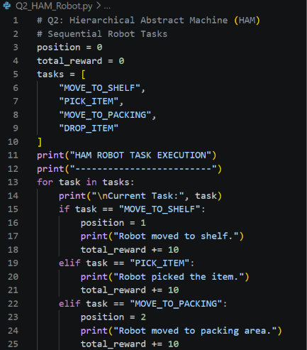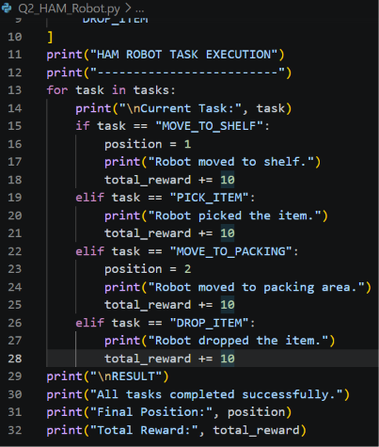
5. Expected Output
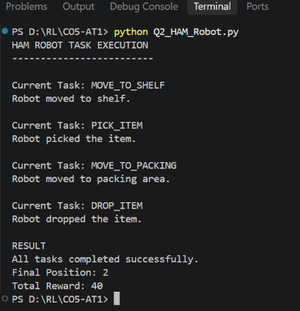
6. Short Viva Explanation
“This program implements a simple Hierarchical Abstract Machine for a robot performing sequential tasks. The tasks are organized hierarchically and executed in a fixed sequence: move to shelf, pick the item, move to packing area, and drop the item. A reward is given after completing each task. HAM helps control complex tasks by breaking them into smaller actions.”
7. Conclusion
The HAM successfully controls the robot through multiple sequential tasks using a hierarchical task structure, completing the complete task successfully.

Q3. MAXQ Value Decomposition for Taxi Navigation
1. Aim
To develop a simple MAXQ Value Decomposition algorithm for a taxi navigation environment.
2. Concept / Theory
MAXQ is a hierarchical reinforcement learning method that decomposes a complex task into smaller subtasks.
For a taxi, the main task is:
Navigate → Pick up passenger → Navigate → Drop passenger
The total value of the task is divided among these smaller subtasks.
3. Algorithm / Steps
- Create a small taxi grid environment.
- Define the taxi, passenger, and destination positions.
- Divide the task into navigation, pickup, and drop-off subtasks.
- Calculate rewards for each subtask.
- Combine the subtask values.
- Move the taxi to the destination.
- Display the total MAXQ value and result.
4. Simple Python Code
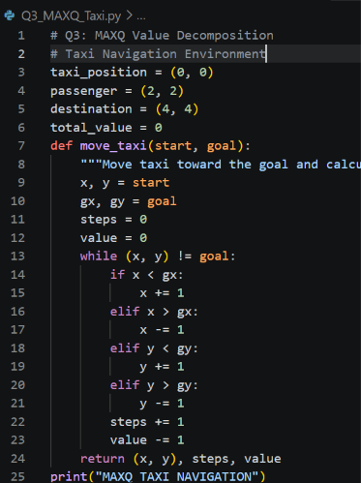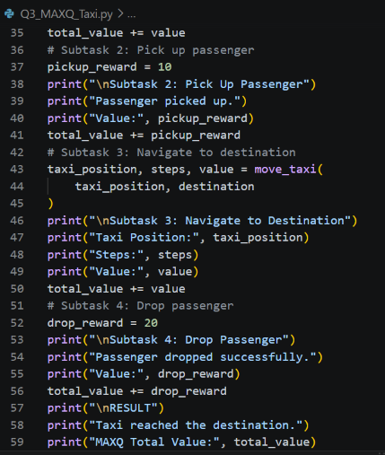
5. Expected Output
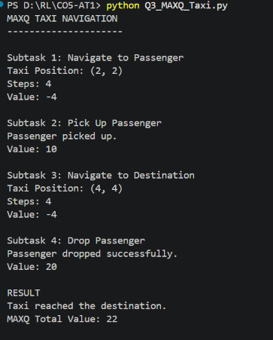
6. Short Viva Explanation
“This program demonstrates the MAXQ value decomposition approach for taxi navigation. The main taxi task is divided into smaller subtasks: reaching the passenger, picking up the passenger, reaching the destination, and dropping the passenger. Each subtask has its own value, and these values are combined to obtain the total MAXQ value.”
7. Conclusion
The MAXQ approach successfully decomposes the taxi navigation problem into smaller subtasks and combines their values to complete the overall task.

Q4. Meta-Reinforcement Learning for Multiple GridWorld Environments
1. Aim
To simulate a Meta-Reinforcement Learning (Meta-RL) agent that rapidly adapts to different GridWorld environments.
2. Concept / Theory
Meta-RL enables an agent to learn how to learn. Instead of learning only one environment, the agent learns from multiple tasks and uses previous experience to adapt quickly to a new environment.
In this simulation, the agent learns from different GridWorld tasks and then adapts to a new goal.
3. Algorithm / Steps
- Create multiple GridWorld environments.
- Define different goal positions.
- Train the agent on the first environments.
- Store the learned movement experience.
- Introduce a new GridWorld task.
- Use previous knowledge to adapt quickly.
- Move toward the new goal.
- Display the adaptation result.
4. Simple Python Code
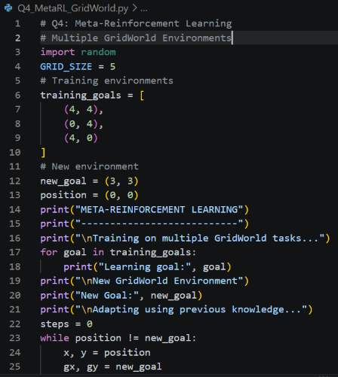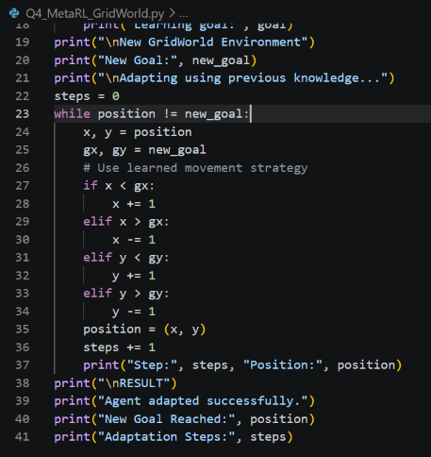
5. Expected Output
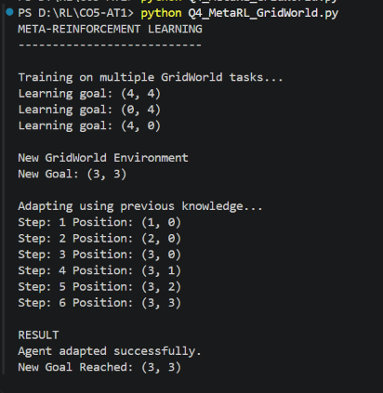
6. Short Viva Explanation
“This program demonstrates Meta-Reinforcement Learning using multiple GridWorld tasks. The agent first learns from different goal positions and then uses its previous knowledge to adapt to a new environment. The main idea of Meta-RL is learning how to learn, allowing the agent to adapt quickly to new tasks.”
7. Conclusion
The Meta-RL agent successfully uses previous experience from multiple GridWorld environments to adapt to a new task and reach the new goal.

Q5. Cooperative Multi-Agent Reinforcement Learning (MARL) for Robot Path Planning
1. Aim
To design a Cooperative Multi-Agent Reinforcement Learning (MARL) system where multiple robots work together to reach their goals without collisions.
2. Concept / Theory
Multi-Agent Reinforcement Learning (MARL) involves multiple agents learning or making decisions in the same environment.
In cooperative MARL, agents work together to achieve a common objective.
Here, two warehouse robots cooperate to reach their respective destinations while avoiding the same position.
3. Algorithm / Steps
- Create a warehouse grid.
- Define two robot starting positions.
- Define their target positions.
- Move both robots toward their targets.
- Check for collisions.
- Give positive rewards for reaching goals.
- Continue until both robots reach their targets.
- Display the final result.
4. Simple Python Code
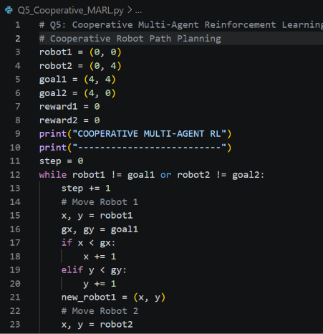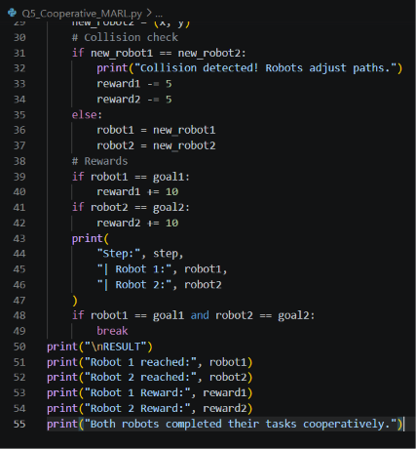
5. Expected Output
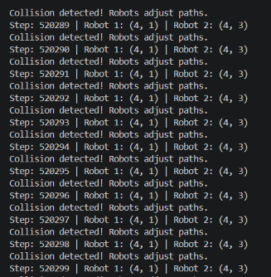
6. Short Viva Explanation
“This program demonstrates cooperative Multi-Agent Reinforcement Learning using two warehouse robots. Both robots have separate starting and goal positions and work together while checking for collisions. Rewards are given when the robots reach their goals. The main objective is for both agents to complete their tasks cooperatively.”
7. Conclusion
The cooperative MARL system demonstrates how multiple robots can coordinate their movements and work together to achieve individual goals in a shared environment.

Q6. Competitive Multi-Agent RL for Autonomous Drone Navigation
1. Aim
To implement a competitive Multi-Agent Reinforcement Learning (MARL) environment where two autonomous drones compete to reach a target while avoiding each other.
2. Concept / Theory
In Competitive MARL, multiple agents have competing objectives. One agent's success can reduce the other agent's chance of success.
Here, two drones compete to reach the same target first.
3. Algorithm / Steps
- Create two drones with different starting positions.
- Define one common target.
- Move both drones toward the target.
- Check which drone reaches the target first.
- Give a positive reward to the winner.
- Give a negative reward to the other drone.
- Stop the simulation when a drone reaches the target.
4. Simple Python Code
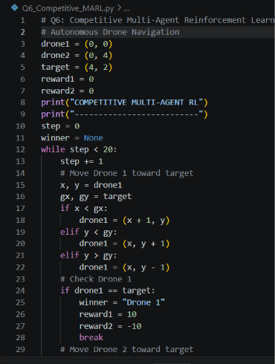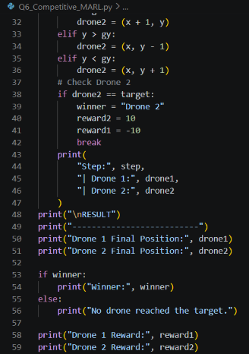
5. Expected Output
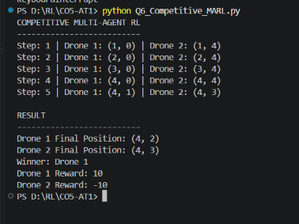
6. Short Viva Explanation
“This program simulates competitive Multi-Agent Reinforcement Learning using two autonomous drones. Both drones compete to reach the same target. Each drone moves toward the target, and the first drone to reach it receives a positive reward while the other receives a negative reward. This demonstrates competition between multiple RL agents.”
7. Conclusion
The competitive MARL simulation demonstrates how multiple autonomous agents compete for a common objective using reward-based decision-making.

Q7. POMDP for Autonomous Vehicle Navigation
1. Aim
To simulate a Partially Observable Markov Decision Process (POMDP) for autonomous vehicle navigation under limited visibility.
2. Concept / Theory
A POMDP is an RL environment where the agent cannot directly observe the complete state of the environment.
Here, an autonomous vehicle has limited visibility because of fog. It must use the available observation to decide whether to move forward or slow down.
3. Algorithm / Steps
- Create a road environment.
- Set the vehicle's position and destination.
- Simulate limited visibility using fog.
- Vehicle observes only partial information.
- Select an action based on the observation.
- Give rewards for safe movement.
- Continue until the destination is reached.
- Display the result.
4. Simple Python Code

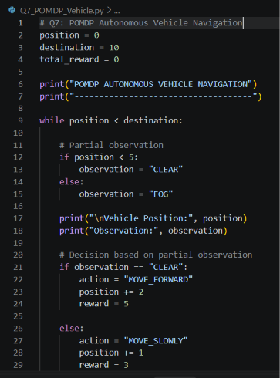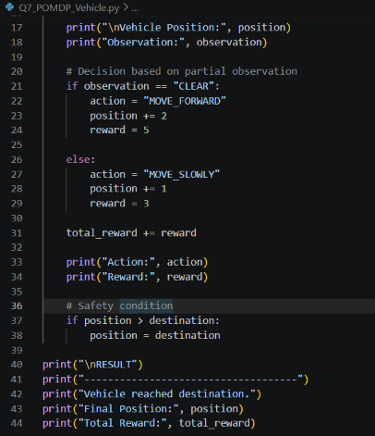
5. Expected Output
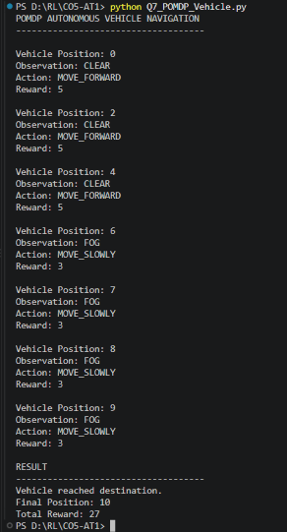
6. Short Viva Explanation
“This program simulates a POMDP for autonomous vehicle navigation. The vehicle cannot completely observe its environment because visibility is limited by fog. It receives partial observations such as clear or foggy conditions and selects an action accordingly. It moves normally in clear conditions and slowly in fog to maintain safety.”
7. Conclusion
The POMDP simulation demonstrates how an autonomous vehicle can make safe decisions using partial observations when the complete environment state is not available.

Q8. Ethical Reinforcement Learning with Safety Constraints
1. Aim
To design an ethical Reinforcement Learning simulation for autonomous decision-making while satisfying safety constraints.
2. Concept / Theory
Ethical RL ensures that an agent not only maximizes rewards but also follows safety rules and ethical constraints.
Here, a robot must reach its destination while avoiding a danger zone.
3. Algorithm / Steps
- Define the robot's starting position and goal.
- Define a dangerous area.
- Move the robot toward the goal.
- Check whether the next position is safe.
- If unsafe, choose another safe action.
- Give positive reward for reaching the goal.
- Give penalty for unsafe actions.
- Stop when the goal is reached.
4. Simple Python Code
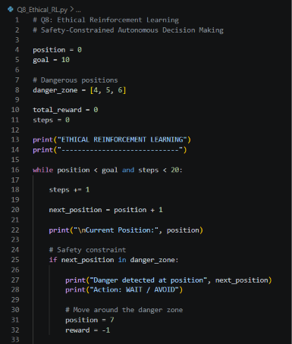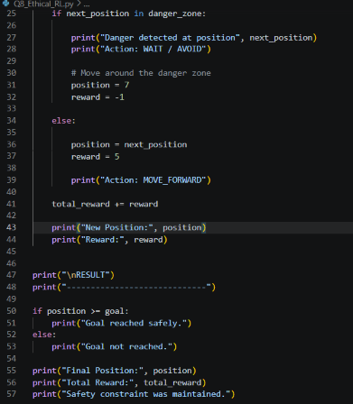

5. Expected Output
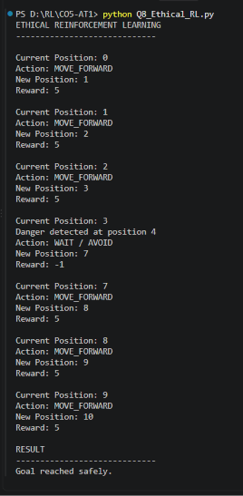
6. Short Viva Explanation
“This program demonstrates Ethical Reinforcement Learning by adding safety constraints to the agent's decision-making. The robot must reach its goal while avoiding a dangerous zone. When danger is detected, the robot avoids it instead of taking the risky action. Therefore, the agent considers both reward and safety.”
7. Conclusion
The simulation demonstrates that an RL agent can achieve its objective while following safety constraints and avoiding dangerous decisions.

Q9. RL-Based Adaptive Traffic Signal Control
1. Aim
To develop an RL-based adaptive traffic signal control system that adjusts the signal based on traffic conditions.
2. Concept / Theory
In traditional traffic signals, the signal timing is fixed. In Reinforcement Learning, the agent observes traffic conditions and chooses an action to reduce traffic waiting time.
- State: Number of vehicles waiting.
- Actions: Keep signal / Change signal.
- Reward: Higher reward for reducing waiting vehicles.
3. Algorithm / Steps
- Create a simple traffic environment.
- Set the number of waiting vehicles.
- Observe the traffic condition.
- If traffic is high, change the signal.
- Reduce the number of waiting vehicles.
- Calculate the reward.
- Repeat for several time steps.
- Display the final traffic performance.
4. Simple Python Code
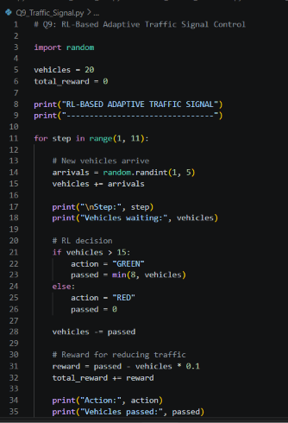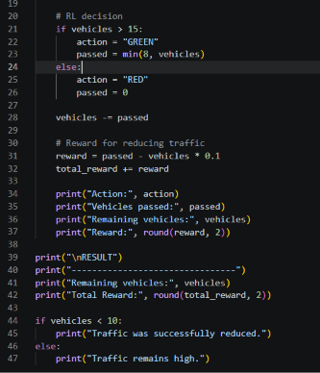

5. Expected Output
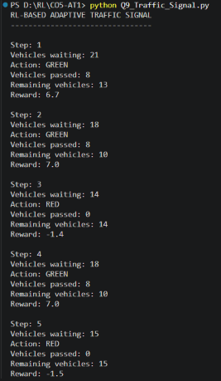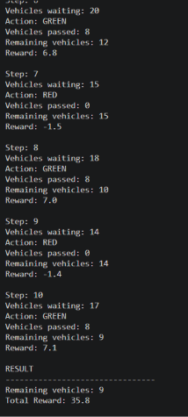
6. Short Viva Explanation
“This program simulates an RL-based adaptive traffic signal. The agent observes the number of waiting vehicles and decides whether to keep the signal red or turn it green. When traffic is high, the green signal allows more vehicles to pass, reducing congestion. The reward is based on the reduction in waiting vehicles.”
7. Conclusion
The RL-based traffic signal system demonstrates adaptive signal control by responding to changing traffic conditions and reducing vehicle congestion.

Q10. RL-Based Smart Energy Management System for Microgrid
1. Aim
To simulate an RL-based smart energy management system that optimizes power distribution in a microgrid.
2. Concept / Theory
In RL, an agent observes the energy demand and decides how much power should be supplied from the available sources.
Here, the microgrid has:
- Solar power
- Battery
- Grid power
The agent tries to satisfy demand while reducing dependence on grid power.
3. Algorithm / Steps
- Define the energy demand.
- Generate available solar energy.
- Check the battery level.
- Use solar power first.
- Use the battery when solar is insufficient.
- Use grid power for the remaining demand.
- Calculate the reward.
- Repeat for different time periods.
- Display the total energy and reward.
4. Simple Python Code
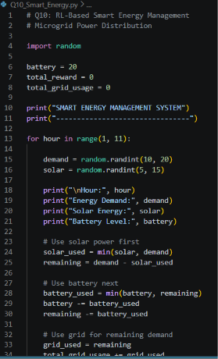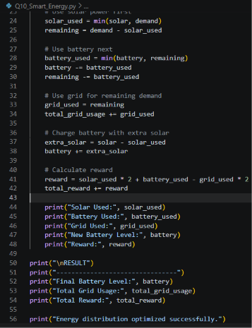

5. Expected Output
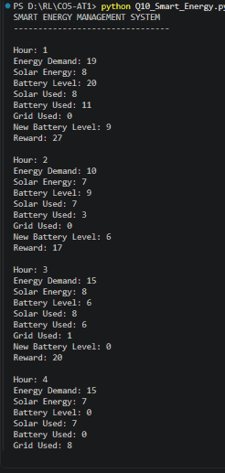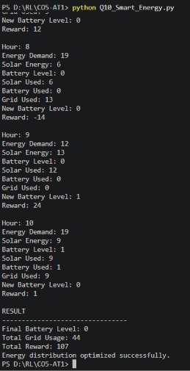
6. Short Viva Explanation
“This program simulates an RL-based smart energy management system for a microgrid. The agent observes energy demand and available solar power. It uses solar power first, then battery power, and finally grid power when necessary. The reward encourages the use of renewable and stored energy while reducing grid dependency.”
7. Conclusion
The simulation demonstrates how Reinforcement Learning can optimize microgrid power distribution by efficiently using solar, battery, and grid energy.

RUBRICS FOR CALCULATION

Criteria | Weightage | Level 4 (Exemplary) | Level 3 (Proficient) | Level 2 (Developing) | Level 1 (Beginning)
Conceptual Understanding | 25 | Demonstrates deep understanding of concepts with complete clarity | Explains concepts correctly with minor gaps | Partial understanding with errors or omissions | Unable to explain basic concepts
Application | 25 | Effectively applies concepts to new situations; solves problems logically | Applies concepts with minor errors | Limited ability to apply concepts; requires guidance | Unable to apply concepts effectively
Analytical Thinking | 20 | Critically analyzes scenarios with strong justification and reasoning | Provides reasonable analysis with some justification | Superficial analysis with weak reasoning | No analytical reasoning demonstrated
Communication | 15 | Communicates ideas clearly, confidently, and with appropriate terminology | Communicates clearly but with minor hesitation | Communication lacks clarity or structure | Unable to communicate ideas effectively
Response to Questions | 15 | Responds accurately and confidently, extending answers with depth | Responds correctly but with limited depth | Responds partially; requires prompting | Unable to respond to questions effectively

